**ABSTRACT**

In the modern landscape of computing, Operating Systems (OS) serve as the foundation for user-machine interactions. The integration of Artificial Intelligence (AI) technologies into these systems has shown promising potential in enhancing user experiences, streamlining tasks, and providing personalized assistance. This project aims to develop an AI-powered ChatBot integrated within an Operating System environment to facilitate seamless communication and assistance for users.

The ChatBot leverages Natural Language Processing (NLP) algorithms and machine learning techniques to understand user queries, provide relevant responses, and execute commands within the OS environment. Through continuous learning and adaptation, the ChatBot evolves its responses based on user interactions, thereby improving its effectiveness over time.

Key functionalities of the Operating System ChatBot include system navigation assistance, troubleshooting support, application management, file operations, and personalized recommendations. By intelligently analyzing user behavior and preferences, the ChatBot assists in optimizing system resources, enhancing productivity, and simplifying complex tasks.

Furthermore, the project emphasizes the importance of privacy and security by implementing robust measures to safeguard user data and prevent unauthorized access. Through encryption protocols and stringent access controls, the ChatBot ensures confidentiality and integrity of user interactions within the OS environment.

The development of an AI-powered ChatBot within the Operating System represents a significant advancement in user-centric computing, offering a more intuitive and efficient way for users to interact with their devices. By harnessing the capabilities of AI, this project aims to redefine the user experience paradigm in Operating Systems, paving the way for future innovations in human-computer interaction.

**TABLE OF CONTENT**

#### CHAPTER NO. TITLE PAGE NO CERTIFICATE i

DECLARATION ii

ACKNOWLEDGEMENT iii

ABSTRACT iv

CHAPTER-1: INTRODUCTION 3

CHAPTER-2 OVERVIEW OF PROPOSED SYSTEM 4

* 1. Problem Statement
  2. Innovative Ideas of Project
  3. Project Objective

#### CHAPTER-3 PRODUCT OVERVIEW 5

* 1. Users and Stakeholders
  2. Project Perspective
  3. Interface
  4. Constrains

#### CHAPTER-4: REQUIREMENT SPECIFICATRION 6-8

* 1. Hardware and software Requirement
  2. Functional Requirements
  3. Non-Functional Requirements

#### CHAPTER-5: SOURCE CODE AND USER INTERFACE 9-12

6.1 Source Code

6.3 User Interface

#### CHAPTER-6: CONCLUSION AND FUTURE SCOPE 13

* 1. Conclusion
  2. Future Scope

**REFERENCE 14**

**CHAPTER-1**

**INTRODUCTION**

In today's digital age, Operating Systems (OS) serve as the backbone of computing devices, facilitating interactions between users and hardware resources. With the rapid advancements in Artificial Intelligence (AI) technologies, there is a growing interest in integrating AI capabilities directly into operating systems to enhance user experiences and streamline workflows. One such application of AI in operating systems is the development of ChatBots, intelligent conversational agents designed to assist users in navigating, managing, and optimizing their computing environments.

The integration of ChatBots within operating systems represents a significant evolution in human-computer interaction, offering users a more natural and intuitive way to interact with their devices. Unlike traditional graphical user interfaces (GUIs) or command-line interfaces (CLIs), ChatBots leverage natural language processing (NLP) algorithms and machine learning techniques to understand user queries, interpret intentions, and provide contextually relevant responses.

The primary objective of this project is to design and implement an AI-powered ChatBot within an operating system environment, aiming to revolutionize the way users interact with their devices. By harnessing the power of AI, the ChatBot will assist users in performing various tasks, such as system navigation, application management, troubleshooting, file operations, and personalized recommendations. Through continuous learning and adaptation, the ChatBot will improve its effectiveness over time, becoming an indispensable tool for users in optimizing their computing experiences.

Furthermore, the integration of a ChatBot into the operating system introduces new opportunities for enhancing productivity, efficiency, and user satisfaction. By providing real-time assistance and contextual information, the ChatBot empowers users to accomplish tasks more effectively, thereby reducing the cognitive load associated with complex computing operations.

In addition to enhancing user experiences, the project also emphasizes the importance of privacy and security in AI-powered systems. Robust measures will be implemented to safeguard user data, prevent unauthorized access, and ensure compliance with privacy regulations.

Overall, the development of an AI-powered ChatBot within the operating system environment represents a significant step forward in the evolution of computing interfaces. By leveraging the capabilities of AI, this project aims to redefine the user experience paradigm in operating systems, paving the way for more intelligent, intuitive, and user-centric computing environments.

**CHAPTER-2**

**OVERVIEW OF PROPOSED SYSTEM**

The proposed system aims to integrate an AI-powered ChatBot directly into the operating system, revolutionizing user interaction and task execution. This integration will enhance the user experience by providing intuitive assistance and seamless execution of tasks within the operating system environment.

**Problem Statement:**

Traditional operating system interfaces often require users to navigate complex menus or memorize specific commands, leading to inefficiencies and user frustration. Additionally, users may face challenges in troubleshooting issues or managing system resources effectively. The proposed ChatBot addresses these issues by providing natural language interaction and intelligent assistance, thereby streamlining user tasks and enhancing productivity.

**Innovative Ideas of Project:**

1. **Natural Language Interface:** Implementing a ChatBot with advanced natural language processing capabilities to understand and respond to user queries in real-time.
2. **Machine Learning Integration:** Utilizing machine learning algorithms to enable the ChatBot to continuously improve its performance and adapt to user preferences over time.
3. **Context-Aware Assistance:** Providing contextually relevant assistance based on the user's current activities, preferences, and system status.
4. **Privacy-Preserving Design:** Implementing robust security and privacy measures to protect user data and ensure confidentiality in ChatBot interactions.
5. **Multi-Platform Compatibility:** Designing the ChatBot to be compatible with various operating system platforms, including desktop, mobile, and web environments.

**Project Objectives:**

1. **Develop an AI-Powered ChatBot:** Create a ChatBot with natural language processing capabilities to understand and respond to user queries within the operating system environment.
2. **Implement Task Execution Module:** Design and implement a module to translate user queries into executable commands, enabling the ChatBot to perform various tasks within the operating system.
3. **Integrate Machine Learning Algorithms:** Integrate machine learning algorithms to enable the ChatBot to learn from user interactions and improve its performance over time.
4. **Ensure Privacy and Security:** Implement robust security measures to protect user data and ensure confidentiality in ChatBot interactions.

**CHAPTER-3**

**PRODUCT OVERVIEW**

The proposed product is an AI-powered ChatBot seamlessly integrated into the operating system environment, designed to enhance user interaction, productivity, and overall computing experience. The ChatBot serves as an intelligent assistant, capable of understanding natural language queries, providing contextual responses, and executing various tasks within the operating system.

**Key Features:**

1. **Natural Language Interaction**: Users can communicate with the ChatBot using natural language queries, eliminating the need for memorizing complex commands or navigating through menus.
2. **Task Execution**: The ChatBot can perform a wide range of tasks within the operating system environment, including system navigation, application management, file operations, troubleshooting, and personalized recommendations.
3. **Personalized Assistance**: Leveraging machine learning algorithms, the ChatBot provides personalized assistance tailored to the user's preferences, behavior, and context, offering relevant suggestions and guidance.
4. **Multi-Platform Compatibility**: The ChatBot is designed to be compatible with various operating system platforms, ensuring a consistent user experience across desktop, mobile, and web environments.
5. **Continuous Improvement**: Through machine learning, the ChatBot continuously learns from user interactions, improving its performance, accuracy, and relevance over time.
6. **Privacy and Security**: Robust security measures are implemented to safeguard user data and ensure confidentiality in ChatBot interactions, protecting against unauthorized access or data breaches.

Top of Form

## CHAPTER- 4

## REQUIREMENT SPECIFICATION

#### SOFTWARE REQUIREMENT*:-*

VMware

Linux is a Unix-like, open source and community-developed operating system (OS) for computers, servers, mainframes, mobile devices and embedded devices. It is supported on almost every major computer platform, including x86, ARM and SPARC, making it one of the most widely supported operating systems.

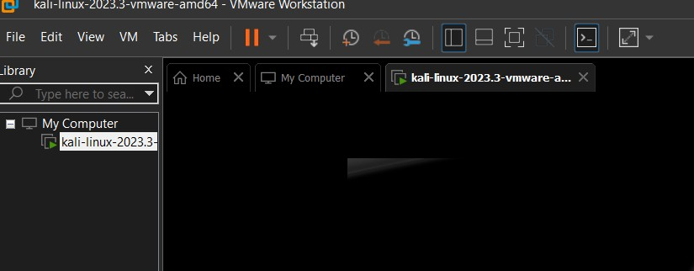

**JDK Environment:**

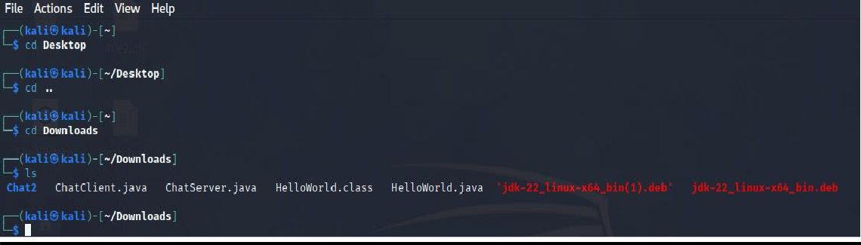

* 1. **HARDWARE:**

DESKTOP/LAPTOP

A desktop helps to fast run the source and display ChatBot.

**Functional Requirements:**

1. **Natural Language Processing (NLP)**:
   * The ChatBot must accurately interpret and understand natural language queries from users.
   * It should support various languages and dialects to cater to a diverse user base.
2. **Task Execution**:
   * The ChatBot should be able to perform a wide range of tasks within the operating system environment, including:
     + System navigation (e.g., opening applications, accessing settings).
     + File operations (e.g., creating, copying, moving, deleting files).
     + Application management (e.g., launching, closing applications).
     + Troubleshooting support (e.g., providing error diagnostics, suggesting solutions).
     + Personalized recommendations (e.g., suggesting relevant applications based on user preferences).
3. **Machine Learning Integration**:
   * Implement machine learning algorithms to enable the ChatBot to learn from user interactions and improve its performance over time.
   * The ChatBot should adapt to user preferences, behavior, and context to provide personalized assistance.
4. **User Interface Integration**:
   * Integrate the ChatBot seamlessly into the user interface of the operating system, allowing users to interact with it through voice commands, text input, or a dedicated interface.
5. **Privacy and Security**:
   * Implement robust security measures to protect user data and ensure confidentiality in ChatBot interactions.
   * Encrypt sensitive information and implement access controls to prevent unauthorized access.

**Non-Functional Requirements:**

1. **Performance**:
   * The ChatBot should respond to user queries promptly, with minimal latency.
   * It should be capable of handling multiple user interactions simultaneously without significant degradation in performance.
2. **Reliability**:
   * The ChatBot should be reliable and available whenever the operating system is running, with minimal downtime or interruptions.
   * It should gracefully handle errors and exceptions, providing informative error messages to users when necessary.
3. **Usability**:
   * The ChatBot interface should be intuitive and user-friendly, catering to users of varying technical expertise.
   * It should provide clear and concise responses to user queries, avoiding ambiguity or confusion.
4. **Scalability**:
   * The ChatBot should be designed to scale with increasing user demand and system complexity, supporting a growing user base and expanding functionality.
5. **Compatibility**:
   * Ensure compatibility with different operating system platforms (e.g., Windows, macOS, Linux) and device types (e.g., desktop, mobile, web).
6. **Maintainability**:
   * The ChatBot should be easy to maintain and update, with modular components that can be modified or extended as needed.

Top of Form

**CHAPTER-5**

**SOURCE CODE AND USER INTERFACE**

**SOURCE CODE:**

import java.util.Scanner;

public class ChatBot {

public static void main(String[] args) {

Scanner scanner = new Scanner(System.in);

System.out.println("Welcome! How can I assist you today?");

while (true) {

String userInput = scanner.nextLine();

String botResponse = getResponse(userInput);

System.out.println(botResponse);

if (userInput.equalsIgnoreCase("exit")) {

System.out.println("Goodbye!");

break;

}

}

scanner.close();

}

public static String getResponse(String userInput) {

String response;

userInput = userInput.toLowerCase(); // Convert input to lowercase for easier comparison

if (userInput.contains("hello") || userInput.contains("hi")) {

response = "Hello there!";

} else if (userInput.contains("how are you")) {

response = "I'm just a bot, but I'm functioning properly, thank you!";

} else if (userInput.contains("weather")) {

response = "I'm sorry, I don't have access to weather data.";

} else if (userInput.contains("time")) {

response = "The current time is: " + getCurrentTime();

} else if (userInput.contains("tell me a joke")) {

response = "Why don't scientists trust atoms? Because they make up everything!";

} else if (userInput.contains("who are you")) {

response = "I'm a simple chatbot programmed in Java.";

} else if (userInput.contains("tell me about java")) {

response = "Java is a high-level, object-oriented programming language "

+ "developed by Sun Microsystems (now owned by Oracle).";

} else {

response = "I'm not sure I understand. Can you please rephrase?";

}

return response;

}

public static String getCurrentTime() {

// This method can be enhanced to get the actual current time

return "Sorry, I don't have access to real-time clock.";

}

}

}

**USER INTERFACE :**

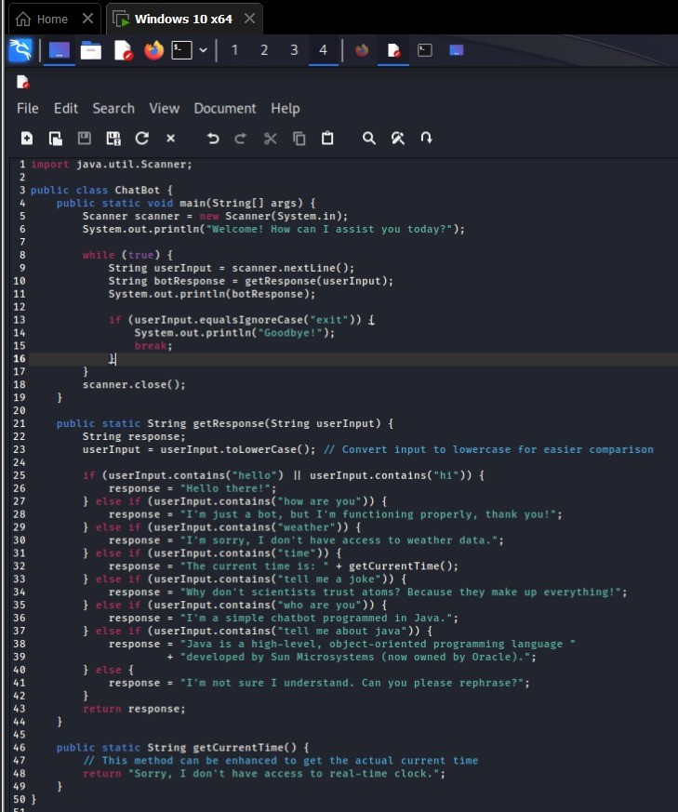

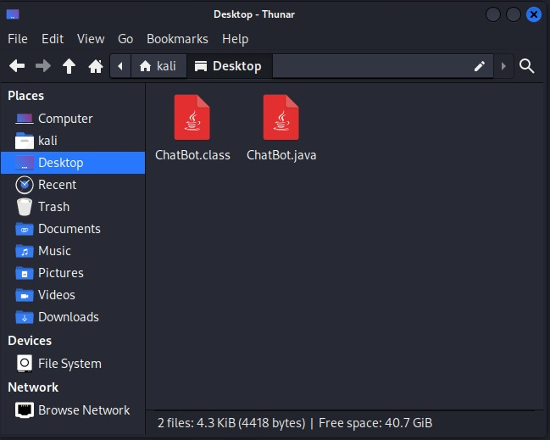

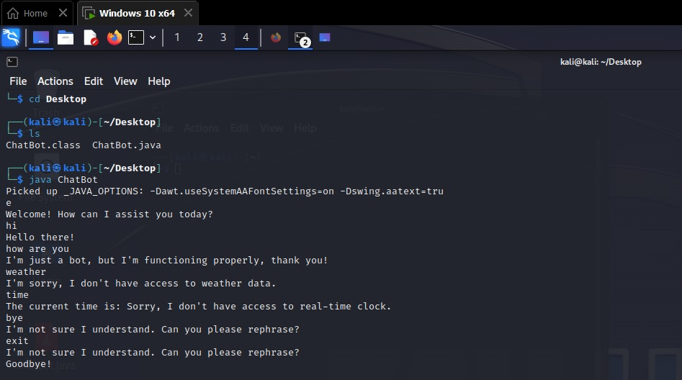**OUTPUT :-**

**CHAPTER-6**

**CONCLUSION AND FUTURE SCOPE**

**Conclusion:**

The integration of an AI-powered ChatBot into the operating system represents a significant advancement in user interaction and task execution. By leveraging natural language processing and machine learning, the ChatBot enhances user experiences, productivity, and accessibility within the computing environment.

**Future Scope**:

Future developments may include advancing natural language processing capabilities, expanding task execution functionalities, enhancing personalization, integrating voice interfaces, ensuring cross-platform compatibility, and exploring enterprise applications. These advancements will further redefine the role of AI in operating systems, offering users a more intuitive and efficient computing experience.

Top of Form

**REFERENCES**

* + - [**https://apastyle.apa.org/style-grammar-**](https://apastyle.apa.org/style-grammar-guidelines/references/examples/conference-presentation-references)[**guidelines/references/examples/conference-presentation-**](https://apastyle.apa.org/style-grammar-guidelines/references/examples/conference-presentation-references)[**references**](https://apastyle.apa.org/style-grammar-guidelines/references/examples/conference-presentation-references)
    - [**https://apastyle.apa.org/style-grammar-**](https://apastyle.apa.org/style-grammar-guidelines/references/examples/conference-presentation-references)[**guidelines/references/examples/conference-presentation-**](https://apastyle.apa.org/style-grammar-guidelines/references/examples/conference-presentation-references)[**references**](https://apastyle.apa.org/style-grammar-guidelines/references/examples/conference-presentation-references)
    - [**https://www.lib.sfu.ca/help/cite-write/citation-style-**](https://www.lib.sfu.ca/help/cite-write/citation-style-guides/apa/conference-proceedings)[**guides/apa/conference-proceedings**](https://www.lib.sfu.ca/help/cite-write/citation-style-guides/apa/conference-proceedings)

**ASSESSMENT**

**Internal:**

|  |  |  |  |  |
| --- | --- | --- | --- | --- |
| **SL_NO** | **Rubrics** |  |  |  |
| 1 | Concept | 10 |  |  |
| 2 | Planning and Execution/  Practical Simulation/ Programming | 10 |  |  |
| 3 | Result and Interpretation | 10 |  |  |
| 4 | Record of Applied and Action Learning | 10 |  |  |
| 5 | Viva | 10 |  |  |
|  | **Total** | **50** |  |  |

***Signature of the Faculty: Signature of the Student:***



#### COURSE OUTCOME (COs) ATTAINMENT

* **Expected Course Outcomes (COs):**

**(Refer to COs Statement in the Syllabus)**

#### Course Outcome Attained:

**How would you rate your learning of the subject based on the specified COs?**



#### 1 2 3 4 5 6 7 8 9 10

**LOW HIGH**

#### Learning Gap (if any):

* **Books / Manuals Referred:**

#### Date: Signature of the Student

* **Suggestions / Recommendations: (By the Course Faculty)**

#### Date: Signature of the Faculty